SMART Develops Rapid Iron Measurement to Improve Cartilage Repair through Cell Therapy

- A novel, rapid and non‑destructive method was developed to provide real-time insights into iron flux in mesenchymal stromal cells (MSCs) using a micromagnetic resonance relaxometry (µMRR) device
- The µMRR device enables highly sensitive monitoring of subtle iron concentration changes in MSCs, which provides an indication of their ability to form quality cartilage tissue
- The study paves the way for more consistent and high-quality manufacturing of MSC-based therapy, a lower cost barrier with the use of an inexpensive benchtop device, and advances clinical translation for cartilage repair
- The research can potentially make MSC-based regenerative treatments more accessible to patients with conditions such as osteoarthritis, chronic joint degeneration conditions and cartilage injuries

Singapore, 26 February 2026 – Researchers from the Critical Analytics for Manufacturing Personalized-Medicine (CAMP), an interdisciplinary research group (IRG) of Singapore-MIT Alliance for Research and Technology (SMART), supported by SMART Antimicrobial Resistance (AMR) IRG and in collaboration with Massachusetts Institute of Technology (MIT) and National University of Singapore (NUS), have developed a first-of-its-kind rapid, non-destructive method to monitor iron flux — the movement and rate at which cells take in, store, use and release iron — in mesenchymal stromal cells (MSCs), which can provide insights within a minute on the cell’s ability to grow cartilage tissue for cartilage repair. This breakthrough offers a promising pathway toward more consistent and efficient manufacturing of high‑quality MSCs used in regenerative therapies, which are used to treat joint diseases such as osteoarthritis, chronic joint degeneration conditions, and cartilage injuries.

Regenerative therapies hold significant promise for patients with the potential to repair damaged tissues rather than simply manage symptoms. However, one of the biggest challenges in bringing these therapies to patients lies in the unpredictable quality of the MSC’s chondrogenic potential — a cell’s ability to develop and form cartilage tissue — during the in vitro manufacturing process.

Even when grown under controlled laboratory conditions, MSCs are prone to losing some of their potential and ability to form cartilage tissue, leading to inconsistent cartilage repair outcomes due to the varying quality of MSC batches. Existing tests that evaluate the quality of MSCs’ cartilage‑forming potential are destructive in nature, which causes irreversible damage to the cells being tested and renders them unusable for further therapeutic or manufacturing purposes.

In addition, the tests require a prolonged up to 21-day period for cells to grow, which slows decision‑making, extends production timelines, and can hinder the timely translation of MSC-based therapies into clinical use and delay treatment for patients. As MSCs can lose chondrogenic potential during this process, early assessment is essential for manufacturers to determine whether a batch should be continued or discontinued. Hence, there is a need for a reliable and rapid method to predict MSCs’ chondrogenic potential during the cell manufacturing process.

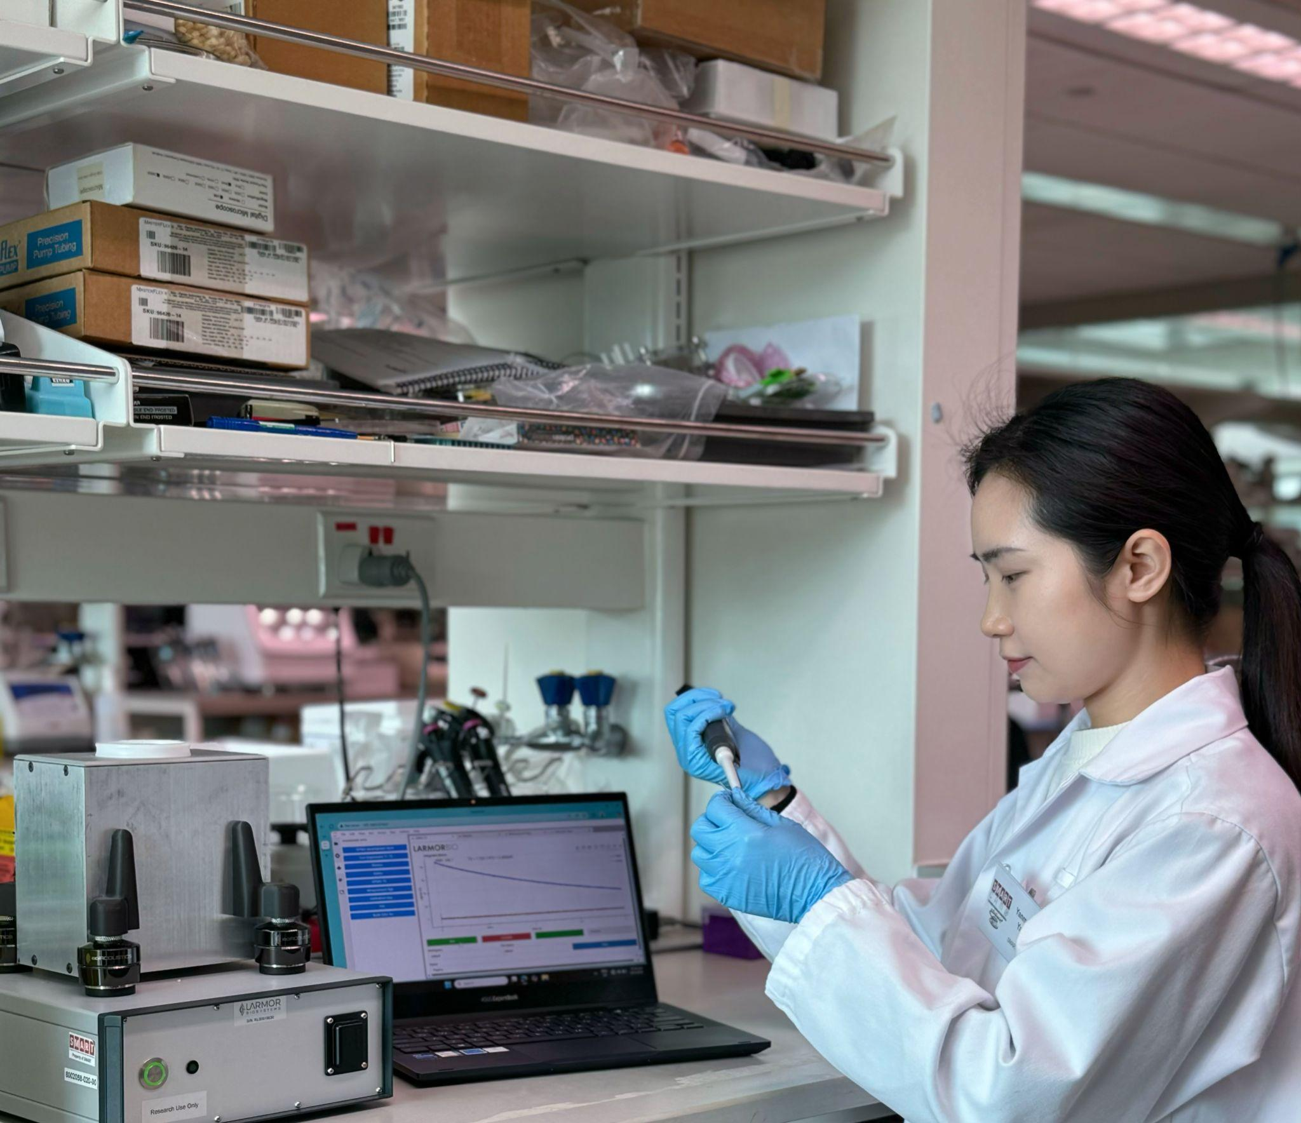
SMART CAMP Postdoctoral Associate Dr Yanmeng Yang using the µMRR device to measure changes in iron levels in MSCs (Photo: SMART CAMP)

In a paper titled “Cellular iron flux measurement by micromagnetic resonance relaxometry as a critical quality attribute of mesenchymal stromal cells”, published in the journal Stem Cells Translational Medicine, the researchers documented the development of a rapid, non-destructive method to monitor iron flux in MSCs by measuring iron changes in spent media — residual components in the culture medium after cell growth. Using an inexpensive benchtop micromagnetic resonance relaxometry (µMRR) device, the approach enables real‑time monitoring of cellular iron changes without damaging the cells. As an inexpensive benchtop device, the µMRR device can be easily integrated into existing laboratories and manufacturing workflows, enabling routine, real‑time quality monitoring without significant infrastructure or cost barriers.

Iron homeostasis is a critical process that maintains normal levels of iron for cell function, maintaining the balance between providing sufficient iron for essential processes, while preventing toxic accumulation. The study found that iron homeostasis is highly correlated with the MSC’s chondrogenic potential, where significant iron uptake and accumulation will reduce the cell’s ability to form cartilage. The researchers also found that supplementing the cell growth process with ascorbic acid (AA) helps regulate iron homeostasis by limiting iron flux, thereby improving the MSC’s chondrogenic potential.

Using this novel method, spent media are collected as samples and treated with AA. The µMRR device is then used to track and provide real-time insights into small iron concentration changes within the spent media. These iron concentration changes reflect how MSCs take up and release iron and can provide an early indicator of whether a batch is likely to succeed in forming good cartilage.

These findings allow manufacturers to not only monitor MSCs quality for cartilage repair in real time, but also to assess when, and to what extent, interventions such as AA supplementation are likely to be beneficial - supporting efficient manufacturing of more effective and consistent MSC‑based therapies.

“One of the key challenges in cartilage regeneration is the inability to reliably predict whether MSCs will retain their chondrogenic potential during manufacturing. Our study addresses this by introducing a rapid, non-destructive method to monitor iron flux dynamics as a novel critical quality attribute (CQA) of MSCs' chondrogenic capacity. This approach enables early identification of suboptimal cell batches during culture, enhancing quality control efficiency, reducing manufacturing costs, and accelerating clinical translation,” said Dr Yanmeng Yang, Postdoctoral Associate at SMART CAMP and first author of the paper.

“Our research sheds light on a fundamental biological process that, until now, has been extremely difficult to measure. By monitoring iron flux in real time without destroying the cells, we can gain actionable insights into a cell batch’s chondrogenic potential, which allows for early decision-making during the manufacturing process. The findings support µMRR‑based iron monitoring as an effective quality control strategy for MSC-based therapy manufacturing, paving the way for more consistent and clinically viable regenerative medicine for cartilage regeneration,” said Professor Jongyoon Han, Co-Lead Principal Investigator at SMART CAMP, Principal Investigator at SMART AMR, MIT Professor and corresponding author of the paper.

This method represents a promising step toward improving manufacturing consistency and functional characterisation of MSC-based cellular products. Beyond advancing cell therapy manufacturing, it contributes to the scientific industry studying iron biology by providing real-time iron flux measurements that were previously unavailable. The research also advances clinical translation of high-quality cell therapies for cartilage regeneration, bringing these closer to patients with joint degeneration conditions and cartilage injuries.

Building on these findings, the researchers plan to carry out future preclinical and clinical studies to expand this approach beyond quality control in manufacturing, with the aim of establishing µMRR as a validated method for the clinical translation of MSC-based therapies in patients for cartilage repair.

The research conducted at SMART was supported by the National Research Foundation Singapore under its Campus for Research Excellence and Technological Enterprise (CREATE) programme.

###

About Critical Analytics for Manufacturing Personalized-medicine (CAMP)
CAMP is a SMART interdisciplinary research group launched in June 2019. It focuses on better ways to produce living cells as medicine, or cellular therapies, to provide more patients access to promising and approved therapies. The investigators at CAMP address two key bottlenecks facing the production of a range of potential cell therapies: critical quality attributes (CQA) and process analytic technologies (PAT). Leveraging deep collaborations within Singapore and MIT in the United States, CAMP invents and demonstrates CQA/PAT capabilities from stem to immune cells. Its work addresses ailments ranging from cancer to tissue degeneration, targeting adherent and suspended cells, with and without genetic engineering.

CAMP is the R&D core of a comprehensive national effort on cell therapy manufacturing in Singapore.

For more information, please visit: https://camp.smart.mit.edu/

About Singapore-MIT Alliance for Research and Technology (SMART) [新加坡-麻省理工学院科研中心]

Singapore-MIT Alliance for Research and Technology (SMART) is MIT’s Research Enterprise in Singapore, established by the Massachusetts Institute of Technology (MIT) in partnership with the National Research Foundation of Singapore (NRF) since 2007. SMART is the first entity in the Campus for Research Excellence and Technological Enterprise (CREATE) developed by NRF. SMART serves as an intellectual and innovation hub for research interactions between MIT and Singapore. Cutting-edge research projects in areas of interest to both Singapore and MIT are undertaken at SMART. SMART currently comprises an Innovation Centre and six Interdisciplinary Research Groups (IRGs): Antimicrobial Resistance (AMR), Critical Analytics for Manufacturing Personalized-Medicine (CAMP), Disruptive & Sustainable Technologies for Agricultural Precision (DiSTAP), Mens, Manus and Machina (M3S), Wafer-scale Integrated Sensing Devices based on Optoelectronic Metasurfaces (WISDOM) and Wearable Imaging for Transforming Elderly Care (WITEC).

SMART research is funded by the National Research Foundation Singapore under the CREATE programme.

For more information, please visit http://smart.mit.edu

For media queries, please contact:
Glenn Tan
SMART@bluetotem.co
+65 9658 5749

