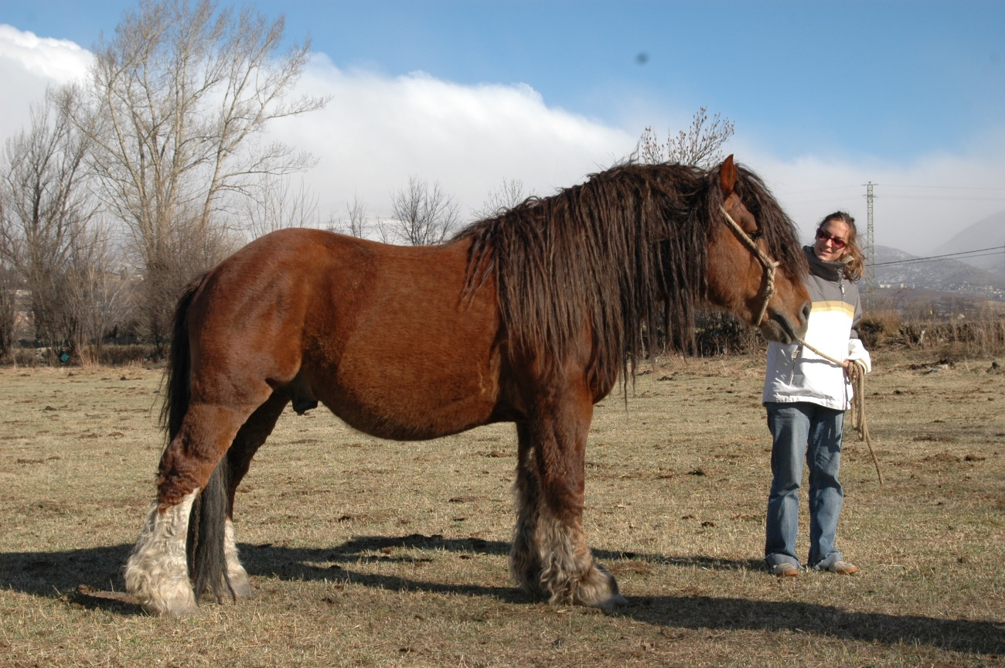
Figure 1. A stallion belonging to CPC, Pyrenean Catalan Horse, breed.

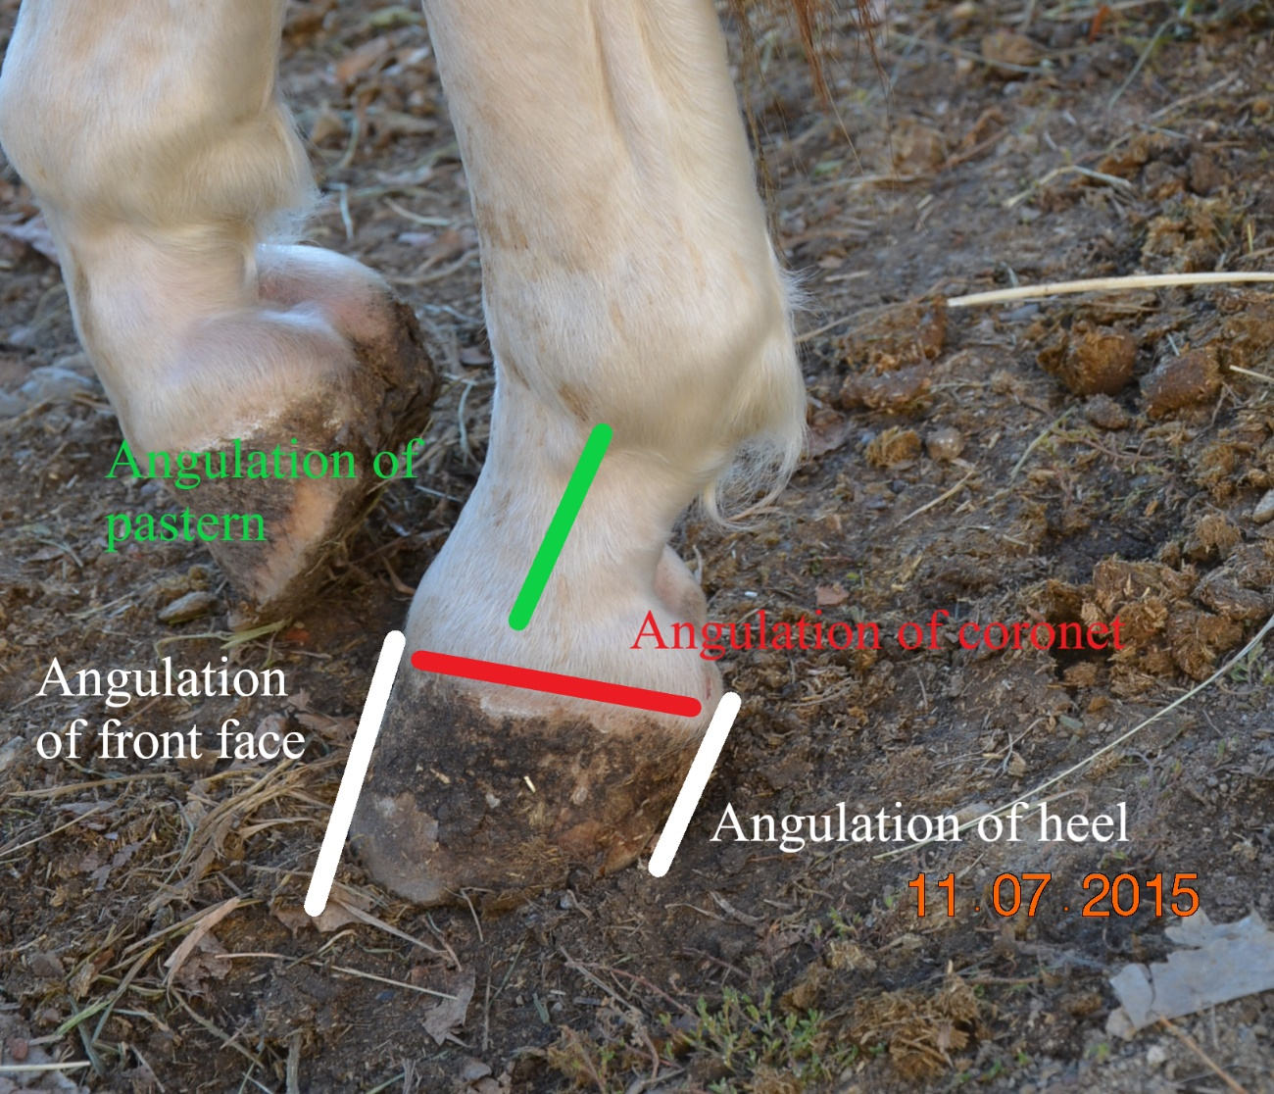
Figure 2. Lateral view of a left front limb. The lines indicate the lines from which angles were measured.

