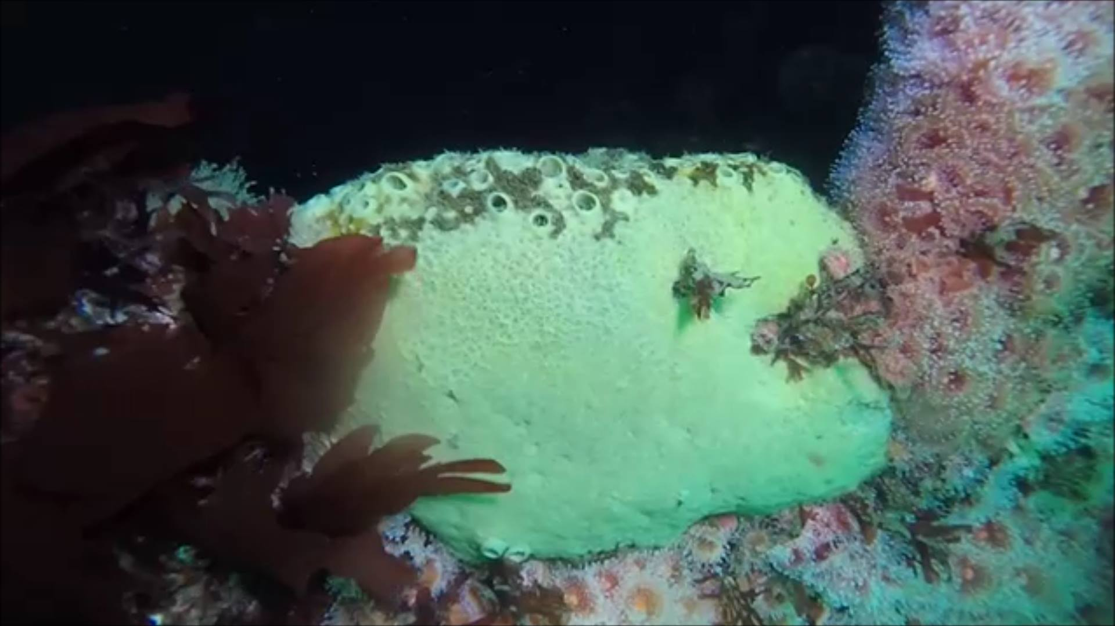
Figure 1: Grey Moon Sponge (Spheciospongia confoederata) Photo credit: Michael Bear

Ocean Sanctuaries is pleased to report that the Yukon Marine Life Survey has identified and confirmed 10 genera of invertebrates using hi definition photography on the artificial reef Yukon, a 366 ft. long Canadian warship sunk off the coast of San Diego in 2000, to act as a marine life aggregator, a goal it has been extremely successful at in the intervening 15 years on the bottom.

This study is a follow up to the one done in 2005 by Ed Parnell of Scripps Institution of Oceanography.1

Ocean Sanctuaries uses photographs submitted by local citizen science divers to document each genus and species. Now we are documenting invertebrates, but beginning next year, Ocean Sanctuaries will begin documenting fish and vertebrates on the vessel.

The genus and species identified and confirmed by marine species experts are as follows:

Flabellina iodinea
Hermissenda crassicornis
Corynactis californica
Lophogorgia chilensis
Metridium senile
Metridium farcimen
Thetys vagina
Parastichopus parvimensis
Loxorhynchus crispatus
Lophogorgia chilensis
Loxorhynchus crispatus

In an unusual occurrence, a diver was able to document a Salp chain (Thetys vagina) floating by (which of course, could not be considered sessile), but was an interesting 'float-by' encounter nonetheless.

Image:Grey Moon Sponge​ (Spheciospongia confoederata) Photo credit: Michael Bear

References:

1. E. Parnell, Ecological Assessment of the HMCS Yukon Artificial Reef off San Diego, CA:http://c.ymcdn.com/sites/www.dema.org/resource/resmgr/imported/S2R-2005-01-EcologicalAssessment-Yukon.pdf

