Sevengill Shark ID Project

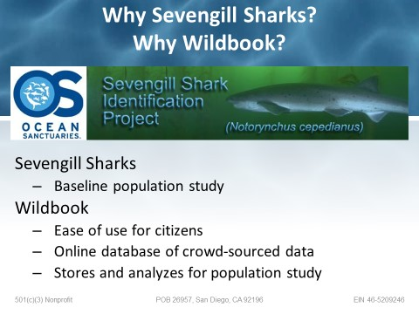

Fig. 1: Wildbook/Credit: Barbara Lloyd

Ocean Sanctuaries is a California nonprofit organization dedicated to creating and supporting marine citizen science projects. In 2010, we began a baseline population study of the Sevengill shark, after hearing reports of encounters between local divers and this species in the San Diego area. According to the IUCN Red List of Threatened Species, the Sevengill Shark (*Notorynchus cepedianus*) is listed internationally as a 'data deficient' species, common in temperate seas worldwide, from the Western coasts of both Americas to Japan, including South Africa.

IUCN Species Distribution Map: <http://maps.iucnredlist.org/map.html?id=39324>

IUCN Red List: <http://www.iucnredlist.org/details/39324/0>

After some investigation, it was determined that no previous baseline population studies had been done of the Sevengill shark in Southern California, we decided to start one of our own, for the benefit of future researchers. This will be a long-term, 5-10 year population dynamics study of this species, which has now been expanded to include False Bay and Mossel Bay, South Africa.

The scientific question we are attempting to answer is: *are the same sharks are returning to the same locations from year-to-year?*

The way it works is that local divers take a camera with them while diving, and if they encounter a Sevengill shark, they take a photograph of the lateral side of the head, if possible, without endangering their safety, as the shark passes by. In this species, around the gill, eye and mouth area of this species, there is a black freckling pattern, which researchers believe is unique to each animal, much as a fingerprint is to a human being and it can be used to identify individual sharks.

Once the photograph is taken, it is uploaded by the diver to an online database designed by information architect **Jason Holmberg**, called ‘**Wildbook,**’ which contains a pattern recognition algorithm, specially designed for recognizing patterns in wildlife markings—it has been successfully tested and used to identify whale sharks (see: <http://whaleshark.org/>).

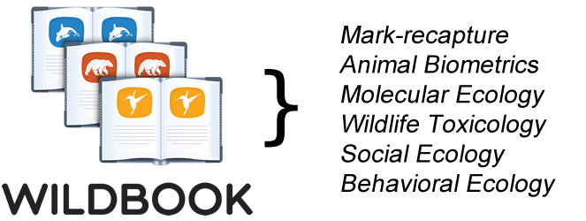

From there, a specially trained Principal Investigator (PI) runs the photograph through the pattern recognition algorithm and compares it to photographs taken previously of other Sevengill sharks in the area, to determine whether or not there is a match. If there is, then, the shark is identified as a unique individual and marked as such.

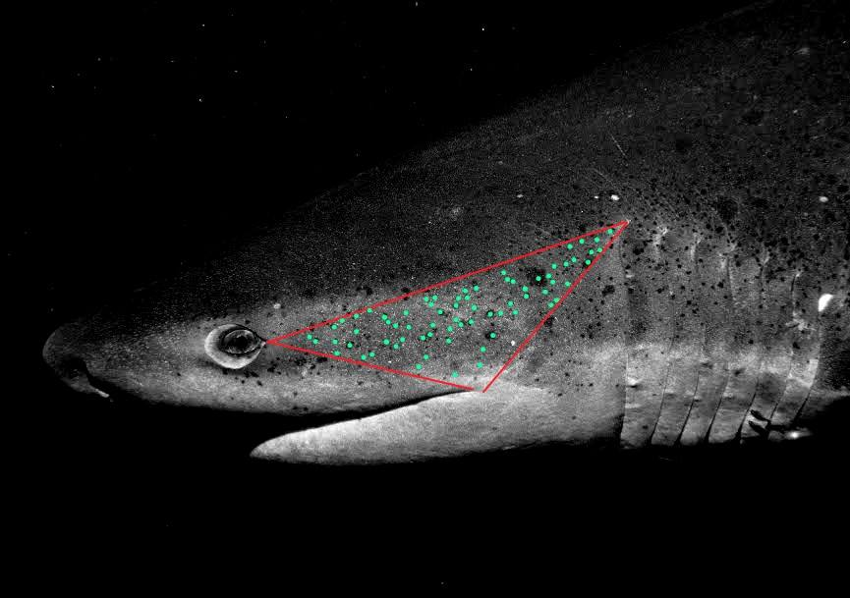

Fig. 2: Sevengill shark photo marked for algorithm processing

So, far the program has proven effective, with the algorithm identifying over 40 individual Sevengill sharks in the San Diego area since 2010.

To participate, South African divers need only go to: <http://sevengillsharksightings.org/> and follow the instructions marked **‘How to Log an Encounter**.’ At least one photograph of a Sevengill shark is required, but, encounters going back several years are not a problem.

Once the encounter has been successfully logged in our database, the user will receive an email confirming the submission.

In the near future, Ocean Sanctuaries is planning an ‘Adopt a (Sevengill) Shark’ program, where users will be able to track individual sharks of their choosing.