**Perspectives in Marine Citizen Science**

**What is Citizen Science?**

There are many different definitions, but probably a good working one would be *the process by which any non-scientist collects data or uses the scientific method under the guidance or mentorship of a scientist.*

It wasn't too long ago that only scientists were considered qualified to gather scientific data--it was simply a scientific axiom. Enter the Cornell Lab of Ornithology, where citizen scientists from all over the world can enter data about their bird sightings and even discover new species.

*More than 200,000 people contribute to the Cornell Lab’s citizen-science projects each year, gathering data on a vast scale once unimaginable. Scientists use these data to determine how birds are affected by habitat loss, pollution, and disease. They trace bird migration and document long-term changes in bird numbers continent wide. The results have been used to create management guidelines for birds, investigate the effects of acid rain and climate change, and advocate for the protection of declining species. (Cornell Lab:* [*http://www.birds.cornell.edu/page.aspx?pid=1664*](http://www.birds.cornell.edu/page.aspx?pid=1664))

Traditionally, academic science has used graduate students to collect data in many cases, but *community science*, the term by which citizen science is also known, has revolutionized the process by which large amounts of data can be collected accurately by large numbers of non-scientists under the training and mentorshipof scientists. There has been some discussion in the scientific community about whether the data collected by citizen scientists is as scientifically valid as data collected by traditional methods and this is a fair question to ask. 1

Citizen science as a discipline, however, has been gaining respectability in the mainstream scientific community. In the latter third of 2015, scientists from the Kepler Space Telescope, partnering with a small army of citizen scientist astronomers, discovered a strange anomaly from a nearby star which had not been noticed before. (The Atlantic: <http://www.theatlantic.com/science/archive/2015/10/the-most-interesting-star-in-our-galaxy/410023/>)

In the world of marine science, citizen science has also been used to monitor the impact of invasive marine species in specific communities. 2 Several marine non-profit organizations, including Reef Environmental Education Foundation (REEF) and Reef Check California, have successfully collected and submitted data using citizen science methods for use in coastal management and marine biology studies.

(REEF.org: <http://www.reef.org/db/publications> and Reef Check: <http://www.reefcheck.org/rcca/reports.php>)

**Marine Citizen Science Groups**

The following is an overview of the two aforementioned citizen science marine groups, examining how they train citizen science divers and collect data.

**REEF**

According to their website, REEF's mission is *to conserve marine ecosystems for their recreational, commercial, and intrinsic value by educating, enlisting and enabling divers and other marine enthusiasts to become active stewards and citizen scientists. REEF links the diving community with scientists, resource managers and conservationists through marine-life data collection and related activities.*

(REEF's website: <http://www.reef.org/about>)

REEF uses a technique called the **Roving Diver Technique** whereby, after taking classes in local marine life identification, divers are turned loose to dive wherever they please to identify local marine life on specially prepared waterproof marine life data sheets prepared by Reef. The goal is to find as many species as possible so divers are encouraged to look under ledges and up in the water column. At the conclusion of each survey, each recorded species is assigned one of four categories based on about how many fish were seen throughout the dive: [single (1), few (2-10), many (11-100), and abundant (>100)].

(Reef Roving Diver Technique: <https://www.reef.org/data/surveyproject.htm#REEF%20Fish%20Survey>).

This method has the advantage of not requiring the diver to do *exact* fish counts, instead, using 'best guess' estimates, but it is dependent upon the diver having accurate knowledge of local species, making misidentification possible with beginner or non-local divers. However, it should also be said here that Reef has several levels of Roving Diver certification and experienced local divers who have taken the complete series of REEF Fish ID 'Fishinars' (Expert Levels 1-5) can become extremely proficient in identifying local species with a high degree of accuracy. The data has been used in scientific papers:(<http://www.reef.org/db/publications>).

**Reef Check**

The next level up, in terms of rigorousness of training in marine citizen science, is Reef Check. Founded in 1996 by marine ecologist Dr. Gregor Hodgson, the Reef Check Foundation is an international non-profit organization dedicated to conservation of two ecosystems: tropical coral reefs and California rocky reefs. With headquarters in Los Angeles and volunteer teams in more than 90 countries and territories, Reef Check works *to create partnerships among community volunteers, government agencies, businesses, universities and other non-profits. Reef Check goals are: to educate the public about the value of reef ecosystems and the current crisis affecting marine life; to create a global network of volunteer teams trained in Reef Check’s scientific methods who regularly monitor and report on reef health; to facilitate collaboration that produces ecologically sound and economically sustainable solutions; and to stimulate local community action to protect remaining pristine reefs and rehabilitate damaged reefs worldwide.*

(Reef Check: (<http://reefcheck.org/about_RC_Reef/about_us.php>)

Unlike REEF, Reef Check's training is not free and their volunteer divers are required to be recertifiedeach year in order to be able to participate. Also, unlike the Roving Diver Technique of REEF, Reef Check California (RCCA) divers are trained in the use of fixed, 'transect lines' to assess the relative abundance and size distribution of target species and how these parameters are changing over time. Transect lines are lines laid down on the bottom, over a predetermined distance in a fixed location, which permit long-term monitoring of certain target species over time through repeated visits to the survey site.

Based on the California Department of Fish and Wildlife's CRANE monitoring protocol, RCCA survey sites will usually contain three core 30 meter transect lines in each of two habitat zones (offshore and inshore reef), with a maximum depth limit of 60 ft. At these core transects, divers assess fishes, invertebrates, seaweed and substrate, then enter the data on RCCA underwater data sheets.

The training and data collection methods at RCCA are more rigorous and not only require annual recertification, but also require calibration of their divers with an RCCA instructor in order to assure data quality control. Training includes a combination of marine life identification classroom and field sessions. Following completion of the training, graduates are allowed to contribute data to the statewide database and will be eligible to obtain a Reef Check California 'Eco-Diver' Certification from the National Association of Underwater Instructors (NAUI) .

**A Technological Revolution in Marine Citizen Science**

While underwater camera and video systems have been around and available to divers for decades, around 2005, a miniaturization revolution occurred, with the advent of smaller and more lightweight, high definition underwater video and still cameras. Until that time, underwater cameras and especially high definition videocameras were extremely bulky, heavy and difficult to manage, both on land and underwater, sometimes weighing many pounds with the large, underwater housings. With the advent of the Go Pro Hero HD video camera in 2006, bulky video camera technology was shrunk down to the size of a pack of cigarettes and the +/- $300 price tag made high definition video technology available to the masses.

This miniaturization revolution also made accurate data collection for citizenscience diverseasieras well, by allowing them to take high definition photographs of marine life, reducing or eliminating a major source of data bias: the diver. While many marine citizen science training agencies offer excellent marine life and species identification, since they rely on a diver's skill in identifying marine life, they cannot completely eliminate the possibility of misidentification of species.

With the advent of smaller, high definition photographic technology, citizen science divers can now take a photograph or video sequence of the species in question and bring it back for further identification and submission to species experts when in doubt. As mentioned above, this eliminates a major factor in data bias: the ability of the diver to identify a given species while underwater. When doing underwater surveys, without a camera, the diver only gets one chance to make a correct identification. When photographs or video are taken, they can be examined over and over and submitted to an expert when a species is in doubt. It also allows unusual species variations and diseased organisms to be brought to the attention of scientists. This represents a major innovation in accurate data collection by citizen scientists.

**Ocean Sanctuaries and the New Technologies**

In 2014, Ocean Sanctuaries was established as a non-profit organization dedicated

to promoting and supporting marine citizen science projects. When Ocean

Sanctuaries was established, one of the founding principles behind it was to support the latest in available citizen science technologies, including high definition photography and video. Ocean Sanctuaries uses high definition photography as the backbone for all three of its marine species citizen science projects.

1. **'Sharks of California': A Partnership with National Geographic's 'Fieldscope'** **Citizen Science Data Collection Tool**

In 2014, Ocean Sanctuaries began testing National Geographic's latest citizen science data collection tool, known as 'Fieldscope,' which National Geographic describes as .... *an interactive mapping platform that extends the tools of exploration and investigation to everyday science enthusiasts. This digital tool enables citizen scientists to document and understand the world around them––both in the classroom and in outdoor setting.*

(National Geographic: [*http://education.nationalgeographic.com/programs/fieldscope/*](http://education.nationalgeographic.com/programs/fieldscope/) *)*

Working with the Fieldscope team at National Geographic, Ocean Sanctuaries has modified this tool to allow SCUBA divers and snorkelers to document their encounters with Pacific shark species anywhere off the coast of California with a still or video camera. After the encounter is over, the diver can upload a still photo or a video screenshot of the species seen. A drop-down list of Pacific shark species is provided and divers give their best guess as to the species encountered. The photograph is then checked to ensure accuracy. When there are doubts, it is shown to a shark research scientist to ensure accuracy.

Divers also submit data about the encounter, such as approximate location and depth as well as estimated visibility. Except in the case of beaches, where the fixed latitude and longitude coordinates are well-known, geolocation via GPS are by definition approximate, since GPS devices do not work underwater. However, diving from a boat with a GPS device onboard can provide accuracy to within 30-60 ft. under optimal conditions.

The use of Fieldscope is not limited to certified SCUBA divers since snorkelers in shallow water can also use it to identify harmless, shallow-water species of sharks, such as Leopard sharks (*Triakis semifasciata*), commonly seen off California beaches.

**2. Identifying Sevengill Sharks (*Notorynchus cepedianus*) Using Pattern Recognition Algorithms**

Ocean Sanctuaries has also partnered with Jason Holmberg, developer of Wildbook, a web-based application for wildlife data management. Wildbook has been successfully used to identify individual whale sharks (*Rhincodon typus*) around the world (Wildbook for Whale Sharks: <http://www.whaleshark.org/>). Ocean Sanctuaries is now using it to identify Sevengill sharks(*Notorynchus cepedianus*) in the San Diego area. Thus far, 42 Sevengill sharks have been identified using the Wildbook algorithms. (Our unpublished results from Wildbook data output, 8-16-15.)

The basic methodology used is one in which local divers take photographs of Sevengill sharks, preferably close-ups showing a lateral view of the head area, and the photographs are submitted to the pattern recognition algorithms. The algorithms look for unique patterns in the black freckling marks present in and around the head area. The freckling marks are similar to the unique fingerprint patterns found in humans and can be used for identification purposes.

(Sevengill Shark Sightings, Methodology : <http://sevengillsharksightings.org/our-methodology-introduction/>)

**Motivating Citizen Scientists**

One frequently discussed aspect of citizen science is motivation: how to motivate citizen scientists to collect data. Citizen science is driven mainly by personal interest: it stands to reason that if one is not interested in Monarch butterflies, one is probably not going to be collecting data on them. So, it is safe to assume that those recruited to gather data in citizen science are interested in the subject.

Using sharks as an example, many in the scuba diving world are fascinated by these top level, apex predators and while they have a healthy respect for them, they also have a desire to be in their presence. Therefore, motivating scuba divers to document their encounters with sharks is not as hard as it might seem at first; in fact, divers, for the most part, appear to be eager to do so. However, safety above all must be emphasized during the process. Actually, what is difficult is finding the sharks themselves since their populations have been so decimated worldwide over the last few decades due to overfishing and other factors.

**Motivating Citizen Scientists to Record 'Zero Data'**

One area of difficulty is motivating citizen scientists to record what is called 'zero data': namely, recording the absence of a species as opposed to recording the presence of a species. For some, the logic goes: it's difficult enough to detect and record the presence of a species, what sense does it make to record itsabsence? In scientific surveys of a single species in a fixed geographical region, recording theabsence of a species is important for population baseline studies. The problem is motivating the citizen scientist to see the scientific logic behind doing so. Ultimately, it can be as simple as asking the citizen scientist to record either the presence or the absence of a certain species, without going into the technical reasons behind doing so. Assuring them that 'zero data' is needed seems to be sufficient. This tends to simplify the process and still enable the data to be collected.

**Conclusion**

Finally, it can be said that the field of citizen science is one that appears to be coming into its own as a discipline, with motivation supplied by the personal interests of the individuals involved. It has allowed the creation of literally armies of volunteers to collect scientific data which has been proven to be as scientifically reliable as that collected by professional scientists. 3

Figures

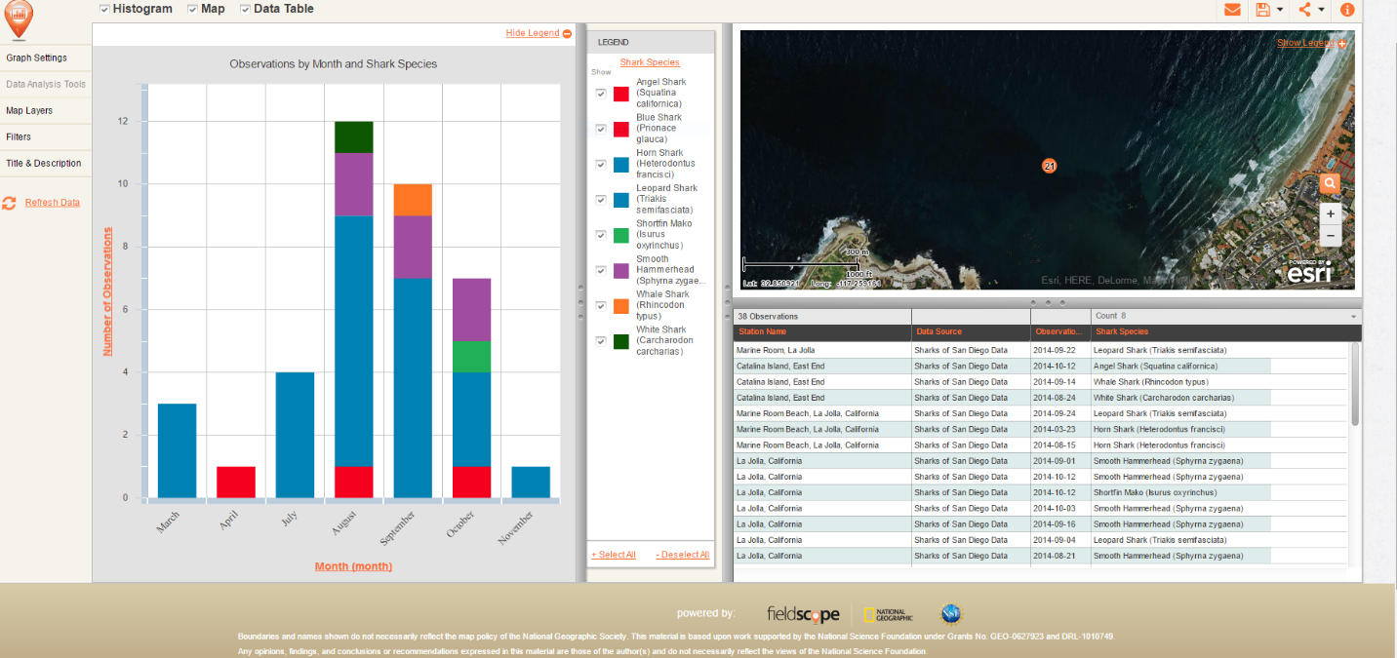

Figure 1: 'Fieldscope Shark Sighting Data

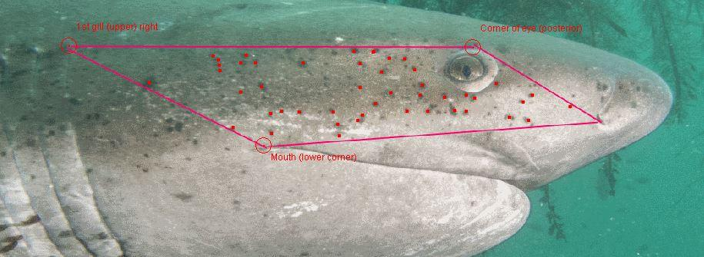

Figure 2: Sevengill shark photo marked for analysis

References

1. **Cohn, J.** 2008. Citizen Science: Can Volunteers Do Real Research? Oxford Journal Science & Mathematics BioScience **58:** 192-197.
2. **Delaney, D., Sperling, C., Adams, C. and Leung B.** 2007. Marine Invasive Species: Validation of Citizen Science and Implications for National Monitoring Networks. Biological Invasions **10:** 117-1
3. **Vianna, G., Meekan, M., Bornovski, T. and Meeuwig**, **J.** April 23, 2014 PLOS ONE: Dive Guides Monitoring Sharks On Coral Reef At Similar Level To Telemetry <http://journals.plos.org/plosone/article?id=10.1371/journal.pone.0095565>